# **How to Install MongoDB on Mac | Install MongoDB on macOS (2024)**

### 

<https://www.youtube.com/watch?v=8gUQL2zlpvI>

DEMO LINK: https://www.awesomescreenshot.com/video/30642594?key=2c60b15ad1555a5b3dcbe1b36ee89d56

### **Method 2: Using Node Version Manager (NVM)**

NVM is a version manager for Node.js, which allows you to install and switch between multiple versions of Node.js effortlessly.

1. Install NVM:  
   Run the following command to install NVM:
2. bash

curl -o- https://raw.githubusercontent.com/nvm-sh/nvm/v0.39.1/install.sh | bash

1. Alternatively, visit the [NVM GitHub page](https://github.com/nvm-sh/nvm) to check for the latest installation script if there's a newer version than v0.39.1.
2. Load NVM:  
   After installation, add NVM to your shell profile. Typically, this involves adding the following lines to your .zshrc or .bash_profile:
3. bash

export NVM_DIR="$([ -z "${XDG_CONFIG_HOME-}" ] && printf %s "${HOME}/.nvm" || printf %s "${XDG_CONFIG_HOME}/nvm")"

[ -s "$NVM_DIR/nvm.sh" ] && \. "$NVM_DIR/nvm.sh" # This loads nvm

1. For Zsh, update .zshrc:
2. bash

nano ~/.zshrc

1. Add the lines to the end of the file, save, and reload the terminal, or source the file directly:
2. bash

source ~/.zshrc

1. Install Node.js:  
   Use NVM to install Node.js:
2. bash

nvm install node

1. This will install the latest version of Node.js. If you need a specific version, replace node with, for example, 14.17.0.
2. Verify Installation:  
   Again, verify by checking the versions:
3. bash

node -v

npm -v

Ls -al

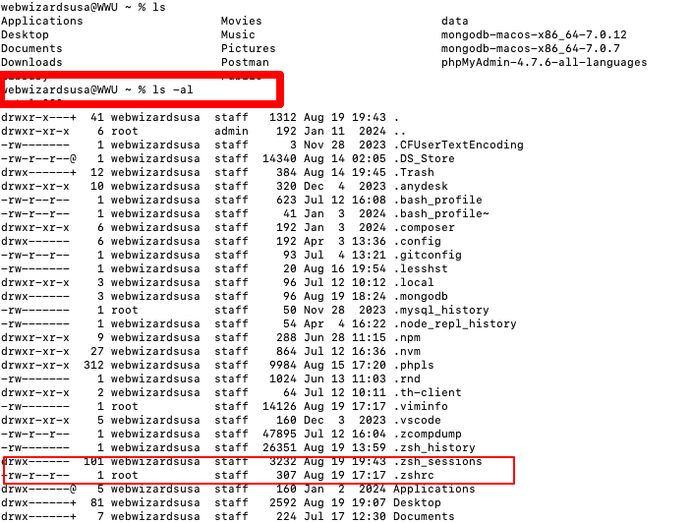

### **/Users/webwizardsusa/mongodb-macos-x86_64-7.0.12/bin**

Sudo mongod --dbpath=/Users/webwizardsusa/data/db

### **mongodb://localhost:27017**

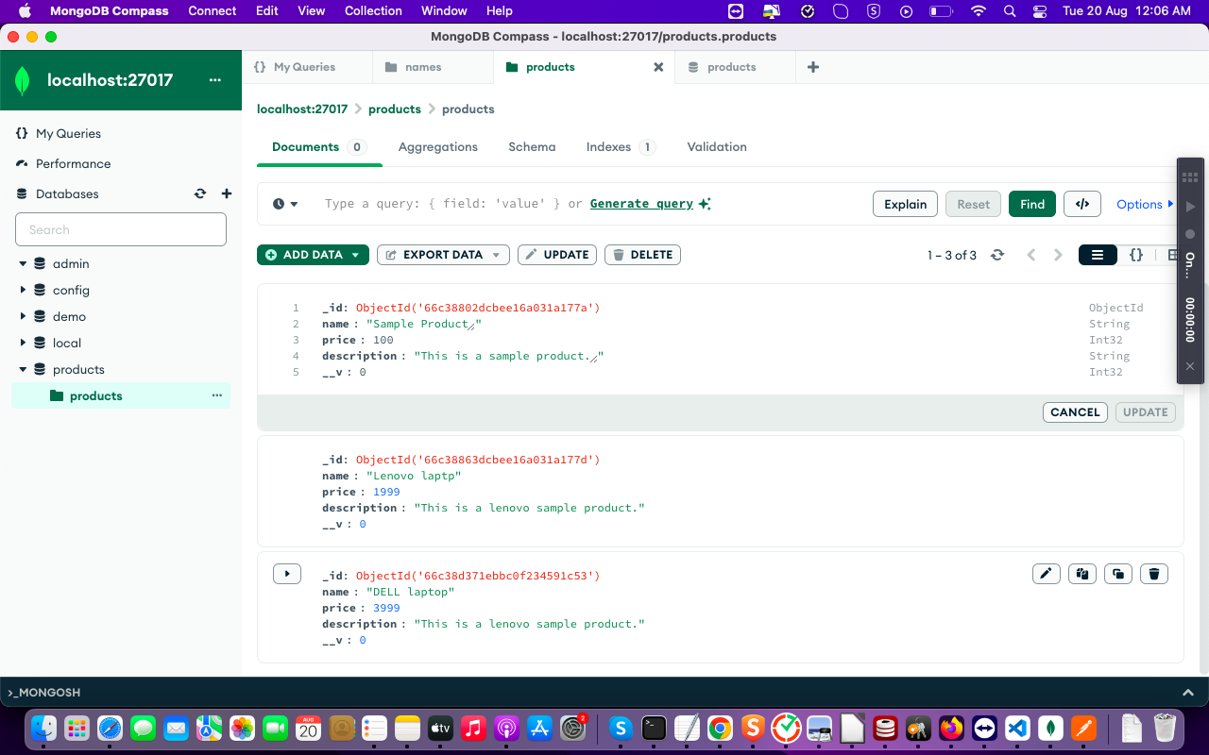

### **show dbs;**

### **admin 40.00 KiB**

### **config 60.00 KiB**

### **demo 8.00 KiB**

### **local 72.00 KiB**

### **use demo**

### **switched to db demo**

### **show collections**

### **names**

### **demo**

### 

### 

### **Step 1: Initial Setup**

1. Initialize Project
2. bash

mkdir express-product-crud

cd express-product-crud

npm init -y

1. Install Dependencies
2. bash

npm install express mongoose multer body-parser express-validator

* + express: Web framework.
  + mongoose: MongoDB ORM for defining schemas and interacting with the database.
  + multer: Middleware for handling file uploads.
  + body-parser: Middleware to parse request bodies.
  + express-validator: Middleware for validating request data.

### **Step 2: Create the Database Schema**

Create a new file models/Product.js:

javascript

const mongoose = require('mongoose');

const productSchema = new mongoose.Schema({

name: {

type: String,

required: true,

minlength: 3,

maxlength: 50

},

price: {

type: Number,

required: true,

min: 0

},

description: {

type: String,

maxlength: 500

},

imageUrl: {

type: String

}

});

module.exports = mongoose.model('Product', productSchema);

### **Step 3: Set Up Express Server and Routes**

Create a server file server.js:

javascript

const express = require('express');

const mongoose = require('mongoose');

const Product = require('./models/Product');

const multer = require('multer');

const bodyParser = require('body-parser');

const { body, validationResult } = require('express-validator');

const app = express();

const upload = multer({ dest: 'uploads/' });

app.use(bodyParser.json());

mongoose.connect('mongodb://localhost:27017/products', {

useNewUrlParser: true,

useUnifiedTopology: true

});

// CREATE a product

app.post('/products', [

body('name').isString().isLength({ min: 3, max: 50 }),

body('price').isFloat({ min: 0 }),

body('description').optional().isString().isLength({ max: 500 })

], async (req, res) => {

const errors = validationResult(req);

if (!errors.isEmpty()) {

return res.status(400).json({ errors: errors.array() });

}

const product = new Product(req.body);

await product.save();

res.status(201).json(product);

});

// GET all products

app.get('/products', async (req, res) => {

const products = await Product.find();

res.json(products);

});

// UPDATE a product by id

app.put('/products/:id', [

body('name').optional().isString().isLength({ min: 3, max: 50 }),

body('price').optional().isFloat({ min: 0 }),

body('description').optional().isString().isLength({ max: 500 })

], async (req, res) => {

const errors = validationResult(req);

if (!errors.isEmpty()) {

return res.status(400).json({ errors: errors.array() });

}

const product = await Product.findByIdAndUpdate(req.params.id, req.body, { new: true });

if (!product) {

return res.status(404).send('Product not found');

}

res.json(product);

});

// DELETE a product by id

app.delete('/products/:id', async (req, res) => {

const product = await Product.findByIdAndDelete(req.params.id);

if (!product) {

return res.status(404).send('Product not found');

}

res.status(204).send();

});

// FILE UPLOAD to a product

app.post('/products/:id/upload', upload.single('image'), async (req, res) => {

const product = await Product.findById(req.params.id);

if (!product) {

return res.status(404).send('Product not found');

}

product.imageUrl = `/uploads/${req.file.filename}`;

await product.save();

res.json(product);

});

// Start the server

app.listen(3000, () => {

console.log('Server running on port 3000');

});

### **Explanation**

* CRUD Operations: Implemented via standard HTTP methods (GET, POST, PUT, DELETE).
* Validation: Utilizes express-validator to ensure that incoming data meets the schema requirements.
* File Uploads: Uses multer to handle file uploads, storing them in an uploads/ directory and associating the file path with a product.

### **Running the Project**

1. Start MongoDB if it's not already running:
2. bash

mongod

1. Run the Express Server:
2. bash

node server.js

With these steps, you have a basic Express.js project to handle CRUD operations, file uploads, and data validation for a Product resource. You can expand this example further by adding additional features or integrating with front-end applications as needed.

##### end ####

If you see the error zsh: command not found: mongod, it means that MongoDB is not installed, or its binaries are not properly set in your system PATH. Here’s how you can install MongoDB on a macOS system using Homebrew, which is a package manager for macOS:

### **Step-by-Step Installation of MongoDB using Homebrew**

1. Install Homebrew:  
   If you don’t have Homebrew installed, open your terminal and run the following command to install it:
2. bash

/bin/bash -c "$(curl -fsSL https://raw.githubusercontent.com/Homebrew/install/HEAD/install.sh)"

1. Add MongoDB Tap:  
   MongoDB is no longer part of the default Homebrew repository, so you need to add the mongodb/brew tap first:
2. bash

brew tap mongodb/brew

1. Install MongoDB:  
   Use Homebrew to install MongoDB. This will install MongoDB Server, MongoDB Shell, and some other utilities:
2. bash

brew install mongodb-community@5.0

1. (Replace 5.0 with the desired version of MongoDB, if different)
2. Start MongoDB as a Service:  
   Once installed, you can start the MongoDB server using Homebrew’s service management commands:
3. bash

brew services start mongodb/brew/mongodb-community

1. Alternatively, if you prefer running MongoDB manually, you can use:
2. bash

mongod --config /usr/local/etc/mongod.conf

1. Verify Installation:  
   After starting the MongoDB service, verify the installation by connecting to the MongoDB shell:
2. bash

mongo

1. If you see the MongoDB shell prompt (>), the installation succeeded and MongoDB is running.
2. Set MongoDB to Start at Boot (Optional):  
   You can set MongoDB to start automatically when your macOS boots up. This is generally a good idea if you plan to use MongoDB regularly:
3. bash

brew services start mongodb/brew/mongodb-community

### **Troubleshooting Tips**

* PATH Issue: If you receive a command not found error even after installation, confirm that the MongoDB binaries are in your PATH. You can add /usr/local/bin to your PATH in your shell configuration file (.zshrc, .bash_profile, etc.).
* Running Services: Ensure that no other service conflicts with the ports MongoDB uses (default port 27017).
* Logs: If MongoDB fails to start, check the logs at /usr/local/var/log/mongodb/mongo.log for any errors.

Following these steps will install MongoDB on your macOS system and make it ready to run with Homebrew’s service management. Remember to keep MongoDB updated periodically using Homebrew commands (brew update and brew upgrade mongodb-community).

####### “mongod can’t be opened because Apple cannot check it for malicious software” ##

The message “mongod can’t be opened because Apple cannot check it for malicious software” is a security feature of macOS that is part of its Gatekeeper system. This system helps protect your Mac from software that could potentially harm your device by restricting apps that are not from the App Store or are not signed with a recognized developer ID.

Here's how you can work around this issue and open mongod:

### **Method 1: Use System Preferences to Allow the App**

1. Open System Preferences:  
   Go to System Preferences > Security & Privacy.
2. Navigate to the General Tab:  
   Ensure you're on the "General" tab.
3. Allow the App:
   * You should see a message at the bottom similar to "mongod was blocked from use because it is not from an identified developer."
   * Click on the "Open Anyway" button next to this message.
4. Re-launch mongod:  
   Try running mongod again:
5. bash

mongod --config /usr/local/etc/mongod.conf

### **Method 2: Use the Terminal to Bypass Gatekeeper Temporarily**

If the above method doesn't work or if you want to use Terminal entirely, you can use the command line to open MongoDB:

1. Run the MongoDB Command:  
   Use the following command to run mongod, acknowledging all security prompts:
2. bash

sudo xattr -rd com.apple.quarantine /usr/local/bin/mongod

1. This command removes the quarantine attribute from the mongod binary, which is the attribute that tells macOS the app was downloaded and needs checking.

### **Method 3: Use the Context Menu (Quick Alternative)**

1. Locate MongoDB in Finder:  
   Navigate to /usr/local/bin in Finder, or wherever mongod is installed. This path might vary depending on how MongoDB was installed.
2. Open the Application via Right-Click:
   * Right-click or Control-click mongod.
   * Select Open.
   * Confirm again when prompted.

This action should bypass the Gatekeeper warning for this instance.

### **Important Notes**

* Background Information: This Gatekeeper warning often appears when software isn't notarized by recognized developers, or when it's a command-line tool without a graphical interface.
* Security Considerations: Always ensure that you're downloading software from trustworthy sources to avoid security risks.
* Repeat Understanding: If the app is updated or reinstalled, you might have to repeat these steps.

By following these steps, you can run mongod on your macOS device even if it's blocked by Gatekeeper.